DATA ANALYSIS – DELIVERY 2

Visualize data in Tableau

First of all we are going to see the hitmap of one of the players. Here we can see the main path the player followed during his sesión. It’s important to hightlight that he spotted the shortcut and used it.

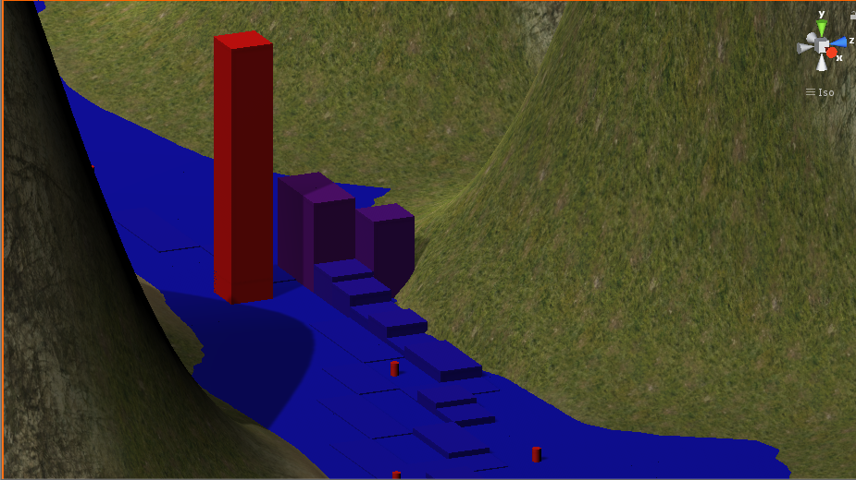

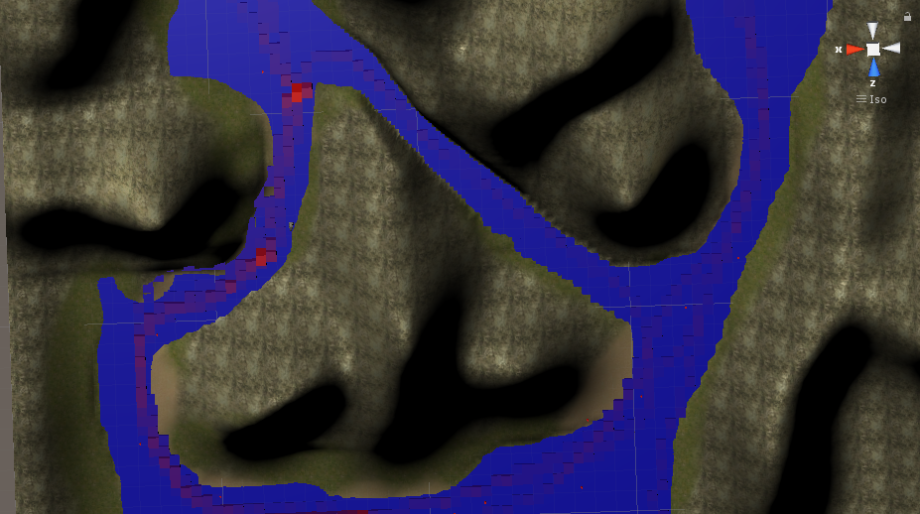

In our Project we extract 4 different types of data: positions, sessions, hits and rounds. So, our main objective is to analyze how many rounds and hits have players per session and also the velocity to know if the game is fun or boring and also know how our players play.

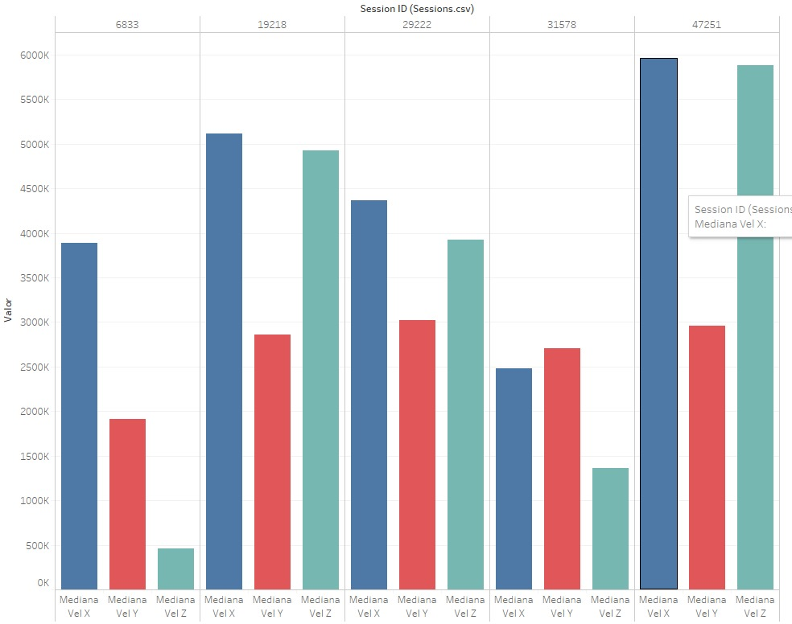

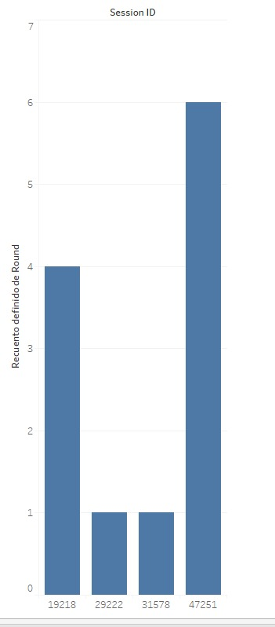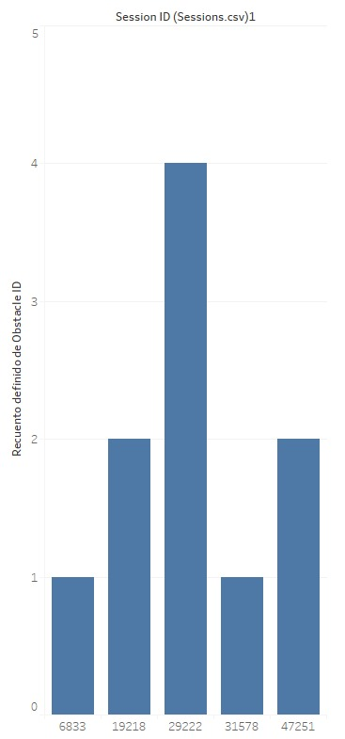In the previous graphs we are computing number of rounds per session and hits per session. As we can see number of rounds doesn’t mean more hits it all depends on player skills. Also, we can check that everybody completes the first round. But the number of total rounds per player is pretty low. Here is when we have to consider if game is fun. Finally, we have the average velocity per session.

Here we can see that the player who has a slower average of velocity hits the car less. This maybe means that rather than the game is not fun maybe there are a lot of obstacles. Players who hit les play the game more!